Md Mahmudul Hasan
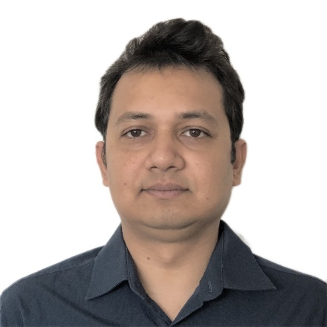
PhD Candidate
Food and Human Nutritional Sciences
University of Manitoba
110-2395 Pembina Highway, Winnipeg, R3T 2H4, Canada
hasanmm@myumanitoba.ca
Cell: +14319986564

Personal background
I have completed my Bachelor of Science and Masters of Science from the department of Biochemistry and Molecular Biology, Jahangirnagar University, Savar, Dhaka-1342, Bangladesh. After completing my M.Sc. degree, I taught at the same department as a lecturer and assistant professor for almost six years. Currently, I am enrolled in PhD program started from fall 2017 at the department of Food and Human Nutritional Sciences, University of Manitoba, Winnipeg, Canada and conducting my research works, especially in the area of meat science under the supervision of Dr. Argenis Rodas-Gonzalez. Till now, I have contributed on 20 articles published in different peer-reviewed journals and 5 conference papers as well.

List of previously received scholarships and awards
- Travel Award, Faculty of Graduate Studies, University of Manitoba, 2019
- Travel Grant Scholarship, Bangladesh Sweden Trust Fund, Economic Relations Division, Bangladesh, 2018.
- International Graduate Student Scholarship (IGSS), University of Manitoba, 2018.
- University of Manitoba Alumni Association Scholarship, 2018
- University of Manitoba Graduate Fellowship (UMGF), University of Manitoba, 2017.
- International Graduate Student Entrance Scholarship (IGSES), University of Manitoba, 2017.
- University Grants Commission Merit Scholarship, Jahangirnagar University, Bangladesh, 2009.

How meat science impacts on my future career goals:
Being a graduate from Biochemistry and Molecular Biology, the starting of meat science research was a little bit hard for me. Later, I found myself interested and involved with current research works when I was able to connect my previously gained knowledge with meat science. After completing my current Ph. D program, I am planning to continue my research activities in the area of meat science as a post-doctoral fellow or as a researcher at a meat research institute. Based on my acquired knowledge from the Ph. D, I want to work on different storage conditions, shelf-life and packaging techniques of meat. Overall, my future vision is to build up my carrier as a meat biochemist and to contribute especially on the technological improvements in the meat industry.

